Global Superstore Data Analysis using SQL
1.Find the Total revenue, quantities and Profit generated.
SELECT
SUM(Sales) AS Total_Revenue,
SUM(Quantity) AS Total_Quantity FROM superstore;
Output:-
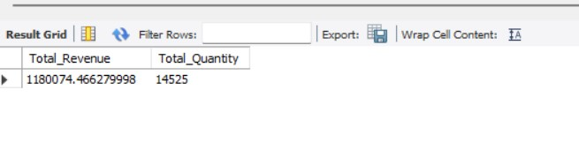2.Find the Segment wise distribution of the Sales.
SELECT segment,
(SUM(sales)) AS total_sales
FROM superstore
GROUP BY segment
ORDER BY total_sales DESC;
Output:-
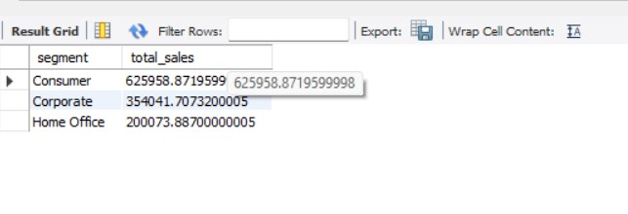
3.Find the top 3 most profitable Products.
SELECT
`Product Name` AS product_name,
ROUND(SUM(profit), 2) AS total_profit
FROM superstore
GROUP BY `Product Name`
ORDER BY total_profit DESC
LIMIT 3;
Output:-
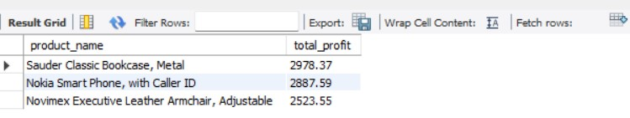
4. How many orders are placed after January 2016.
SE LECT COUNT(*) AS total_orders_after_2016
FROM superstore
WHERE YEAR(`Order Date`) > '2016-12-31';
Output:-
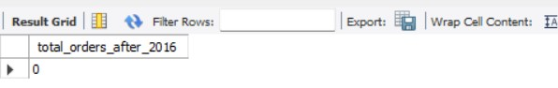
5.How many states from Mexico are under the roof of business?
SELECT
COUNT(DISTINCT state) AS total_states_in_austria FROM superstore
WHERE country = 'Austria';
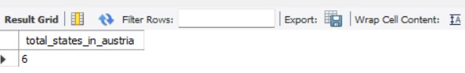
6. which products and subcategories are most and least profitable ?
(SELECT
`Sub-Category` AS sub_category,
`Product Name` AS product_name,
SUM(Profit) AS total_profit
FROM superstore
GROUP BY `Sub-Category`, `Product Name`
ORDER BY total_profit DESC
LIMIT 5
)
UNION ALL
(
SELECT
`Sub-Category` AS sub_category,
`Product Name` AS product_name,
SUM(Profit) AS total_profit
FROM superstore
GROUP BY `Sub-Category`, `Product Name`
ORDER BY total_profit ASC
LIMIT 5
);
Output:-
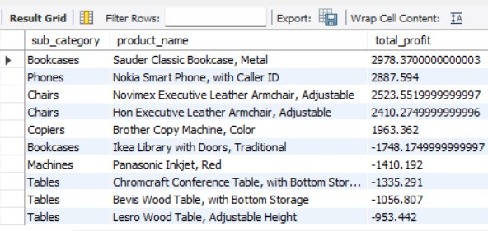

- Which customer segment contributes the most to the total revenue?
SELECT segment,
SUM(sales) AS total_revenue
FROM superstore
GROUP BY segment
ORDER BY total_revenue DESC
LIMIT 1;
Output:-
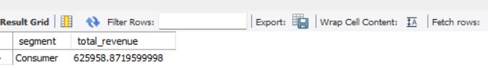
8. What is the year-over-year growth in sales and Profit?
SELECT
YEAR(`Order Date`) AS order_year,
ROUND(SUM(Sales), 2) AS total_sales,
ROUND(SUM(Profit), 2) AS total_profit,
ROUND(
SUM(Sales) - LAG(SUM(Sales)) OVER (ORDER BY YEAR(`Order Date`)),2) AS sales_growth,
ROUND(
SUM(Profit) - LAG(SUM(Profit)) OVER (ORDER BY YEAR(`Order Date`)), 2
) AS profit_growth
FROM superstore
GROUP BY YEAR(`Order Date`)
ORDER BY order_year;
Output:-
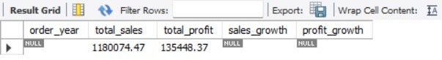

9.Which countries and cities are driving the highest sales?
SELECT
country,
SUM(sales) AS total_sales
FROM superstore
GROUP BY country
ORDER BY total_sales DESC;
Output:-
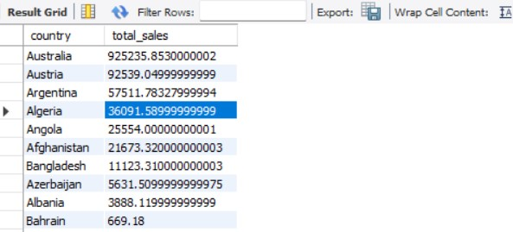

10.What is the average delivery time from order to ship date across regions? SELECT
region,
AVG(DATEDIFF(`Ship Date`, `Order Date`))AS avg_delivery_days
FROM superstore
GROUP BY region
ORDER BY avg_delivery_days;
Output:-
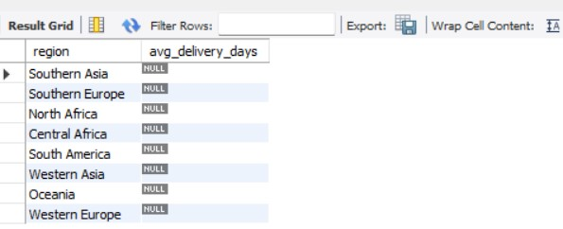

11.what is the profit distribution across order priority?
SELECT
`Order Priority` AS order_priority,
SUM(profit) AS total_profit,
AVG(profit) AS avg_profit_per_order
FROM superstore
GROUP BY `Order Priority`
ORDER BY total_profit DESC;
Output:-

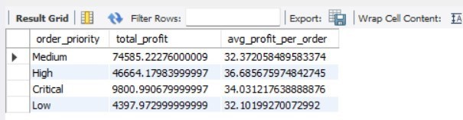

12.Suggest data-driven recommendations for improving profit and reducing losses.
SELECT
`Product Name`,
`Sub-Category`,
SUM(Profit)as Total_Profit
FROM superstore
GROUP BY `Product Name`, `Sub-Category`
HAVING SUM(Profit) < 0
ORDER BY Total_Profit ASC;
Output:-
